This certificate certifies that:

Ormiston Denes Academy

is committed to making a noise to help us stop bullying this Anti-Bullying Week 2023

ABOUT

#ANTIBULLYINGWEEI1

13TH — 17TH NOVEMBER 2022

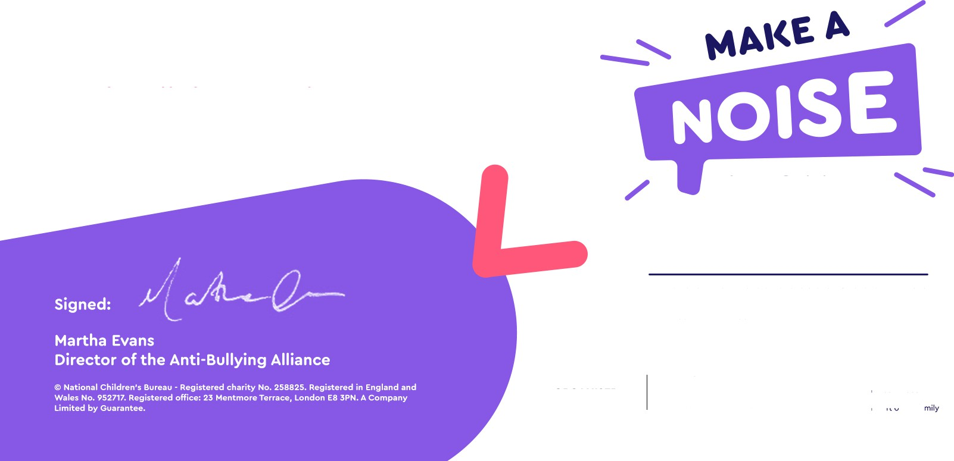

ORGANISER

C ANTI-BULLYING

?? ALLIANCE

NATIONAL CHILDREN'S BUREAU

Pa-' f the fa