Step by Step Guide to adding your placement

Please note: The placement must have been agreed by the employer BEFORE you add the placement, and you will need certain information as shown below;
Process:
- Log onto Unifrog using your school email address and your password (if you have forgotten your password there is a ‘lost password’ option.
- From the home page, scroll down until you come to the ‘Access all the tools’ section.
- Click on the Placements box.
- Click on the Add new placement box.
- Student Initial Form. This asks you if the placement has already been agreed with the employer. You can only proceed further if it has been agreed and you have clicked to confirm ‘yes, I have agreed it with the employer.’
- Basic Details. For this you will need:
  - Placement/Business name.
  - Start Date: 29th June 2026.
  - End Date: 3rd July 2026.
  - Placement Coordinator: Mrs Richings.
  - Your date of birth (it populates this, but check that it is correct).
- Logistics. For this you will need:
  - Time commitment (if it is all week then type Full Time). If it isn’t all week you will need to type what days/hours you will be working.
  - Will you meet the employer in person at any time during the placement? This should be answered Yes, it’s all or part in person.
- Your Objectives. This is what you want to get out of the work experience, what skills you want to develop, what you want to experience whilst there. It needs to be over 25 words. It could be as simple as ‘I want to work at ** as I would like to see what the job entails and what the career opportunities are. I would also like to improve my employability skills and increase my confident.’ But write what it means to YOU.
- Employer Contact details. You will need:
  - Employer placement lead name (normally the person who has agreed the placement).
  - Employer placement lead email address (you need to type this in twice).
  - Employer telephone number, address and postcode.
- You also have to complete:
  - Is this the workplace where you’ll be based throughout the placement? Tick yes, unless you are travelling around when you would then tick no and complete more information.
  - Will you live at home as normal during the placement?
  - How will you travel to and from the placement?
  - Do you have any special needs, illnesses, medical conditions, allergies or injuries that may affect your placement? You need to answer this honestly and sensibly.
  - Your parent/Guardian emergency contact name.
  - Your parent/Guardian telephone number.
  - Your parent/Guardian email address.
There is then a statement which asks: do you agree to:
- Unifrog sending your details to the employer email address you have provided?
- Abiding by the confidentiality, data protection and data security policies held by the employer?
- Observing all safety, security and other policies laid down by the employer?
- Informing the employer and school as soon as possible of any absence?
You have to tick a box to agree to all four points.
Finally it asks if the form is finished, and you have to tick a box to confirm it is finished, and then click on the ‘Add Placement’ button.
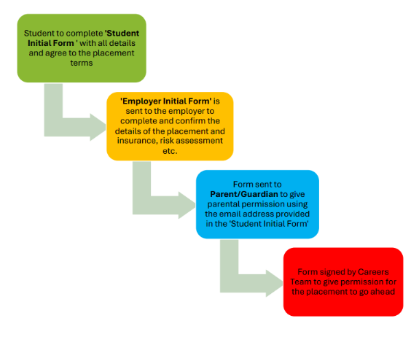
The process then follows these stages:

The placement IS NOT complete until all stages have been confirmed and the academy careers team have given permission online for the placement to go ahead.

Remember, if you need any help, come along and speak to Mrs. Richings, Mr Cooper. or your year team.

